Assignment Submission 22/08/2025
Module code: UFCFMJ-15-M Full Name: ZEKRI Djihene Georgina
Student Number: 25006858
Word count excl. headers, cap>ons, references and annex:2014
1. Introduction
Predicting the number of bicycle rentals is a vital aspect of studying city information and creating smart transportation plans. By correctly guessing how many rentals will occur, city governments can improve how they use resources, lessen traffic problems, and offer better services to people living in the city. The principal objective of the current study concerns the development of a forecasting model capable of estimating hourly bicycle rentals by incorporating temporal and environmental variables, while simultaneously interpreting the influence of key factors on rider behavior.
This study is founded upon the analysis of historical bicycle rental data, recorded hourly throughout the year, integrating information regarding meteorological conditions, time of day, weekends, and seasonal variations. Feature engineering is applied to enhance the model’s predictive power, including the creation of lag variables to capture temporal dependencies and interaction features to reflect combined effects, such as the relationship between temperature and season.
To evaluate predictive performance, both linear and non-linear regression models are employed, including Linear Regression, Random Forest Regressor, and Gradient Boosting Regressor. The goal of this research is to assess the explanatory power of these models regarding differences in bicycle rentals and to pinpoint the elements that have the greatest impact on forecasting. This strategy, which incorporates data analysis, feature creation, and model assessment, ensures a thorough comprehension of rental trends and steers the selection of the best forecasting technique.
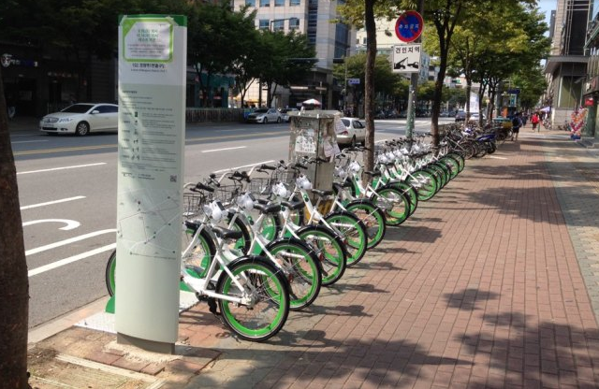

2. Data Exploration
2.1 Initial Data Inspection
The dataset is made up of bike rental data collected every hour for a complete year, which amounts to a total of 8,760 entries. Important data fields include the "Number of Bikes Rented", precise details of the date and time, together with climate-related data such as how hot or cold it is, how much water is in the air, how fast the wind is moving, how bright the sunlight is, rainfall, and frozen rainfall. These attributes deliver a widespread understanding of the atmospheric and time-based elements potentially affecting user needs.
The chosen attributes contained no absent data entries, making the study easier and removing the necessity for data completion. The date column underwent transformation into a datetime arrangement, streamlining the process of deriving time-related characteristics, such as weekday and weekend flags. Classification-based variables like season, vacation, and operational day were translated into numeric form for the early investigation and upcoming model construction.
FIGURE 1: Pairplot for core features
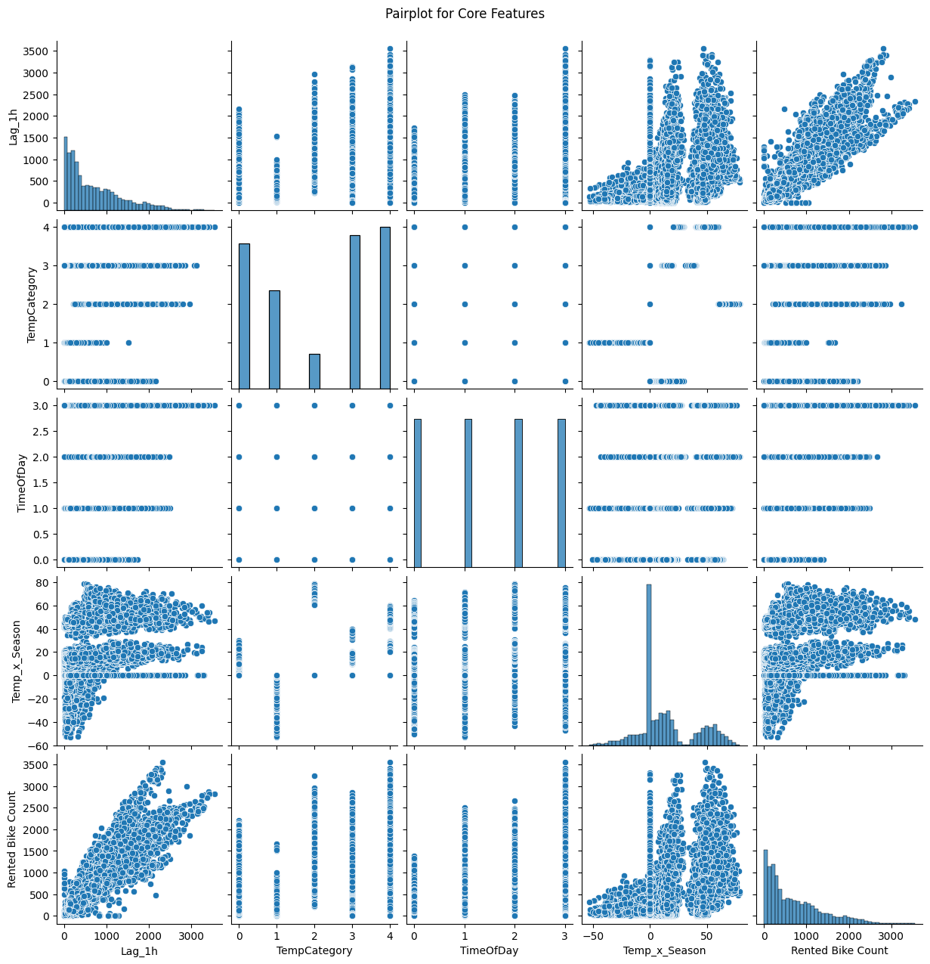
2.2 Descriptive Analysis and Correlation
Based on descriptive statistics, bike rentals are somewhat affected by the time and temperature, whereas other weather elements seem to have less of an impact. A clear pattern throughout the day is seen, with the most rentals happening in the morning and evening, which shows normal commuting habits.
The correlation study shows a significant positive link between what we are trying to predict and time-delayed characteristics, like how many rentals happened in the last hour (Lag_1h), which emphasizes how important recent rental trends are. On the other hand, there are not as strong links with weather factors. These links are clearly shown in a heatmap, which gives a good look at how the different characteristics relate to each other and how they affect the demand for bike rentals.
FIGURE 2: Heatmap of the original correlation matrix
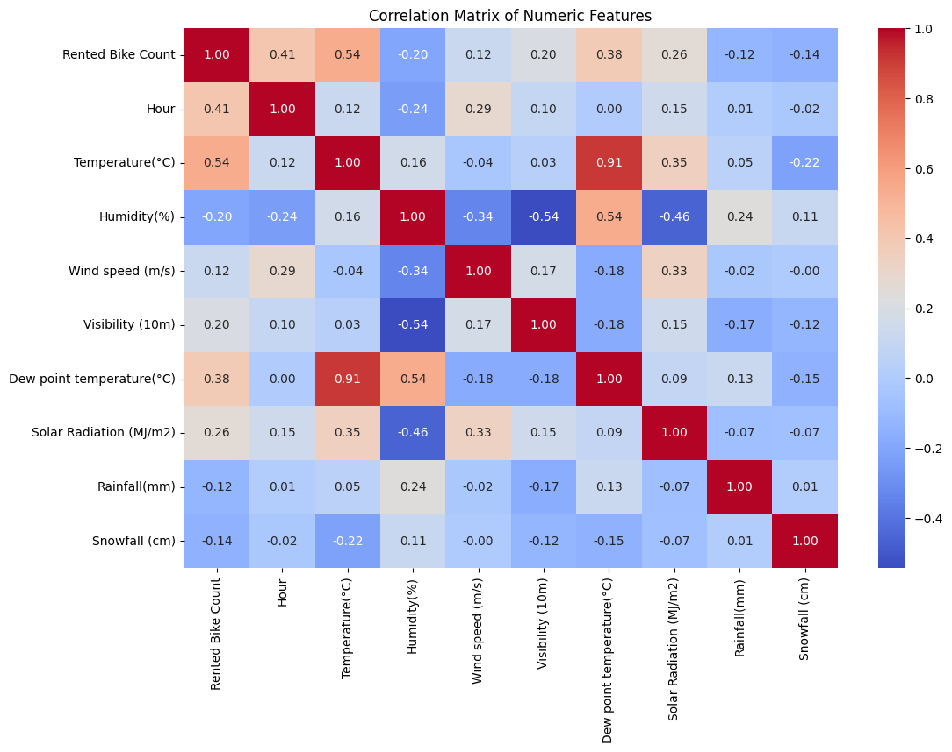

3. Feature Engineering
3.1 Temporal Features
Understanding the demand for bike rentals greatly depends on the temporal patterns observed. To identify trends specific to weekdays and weekends, the characteristics DayOfWeek and Weekend were obtained from the date information. Furthermore, TimeOfDay divides the day into four segments: Night, Morning, Afternoon, and Evening. By using this categorization, the model can factor in daily fluctuations, like the increase in commuters during the early hours and at dusk. These engineered temporal features help the model differentiate between regular daily fluctuations and irregular spikes in demand.
3.2 Weather Features
The way people rent bikes changes a lot depending on the weather. The TempCategory divides temperature into five groups: Freezing, Cold, Mild, Warm, and Hot, showing how different temperatures change how many bikes people want to rent. Weather Condition gives a quick overview of things like rain, snow, and sunshine. By changing these things into numbers, the model can understand how good or bad weather affects bike use. With these features, the prediction models can change their predictions based on weather changes, making them more accurate when it's really hot, cold, or rainy.
3.3 Lag Features
Time-related connections are determined using delay-based characteristics. The 'Lag_1h' characteristic shows the number of rentals from the hour before, and 'Lag_24h' shows the number from the same hour on the day before. These characteristics let the models use recent trends and everyday repeating patterns in bike rentals. The strong link between 'Lag_1h' and what we're trying to predict highlights how important it is to forecast current needs. Adding delay-based characteristics helps both simple and complex models understand quick connections and repeating patterns in the data collection.
3.4 Interaction Features
Interaction features capture combined effects between variables that individual features cannot explain. The Temp_x_Hour and Temp_x_Season configurations represent the merged influence of temperature when considered together with the specific hour and season. In a parallel manner, Hour_x_Weekend takes into account how demand changes on an hourly basis between weekend days and normal weekdays. These interactive elements make it possible for the model to identify connections that are not linear, like a heightened sensitivity to temperature at particular times of day or in specific seasons. By incorporating these attributes, the ability of non-linear models, such as Random Forest and Gradient Boosting, to accurately predict outcomes is greatly improved.

FIGURE 3: Distribution of TempCategory and TimeOfDay vs Rented Bike Count
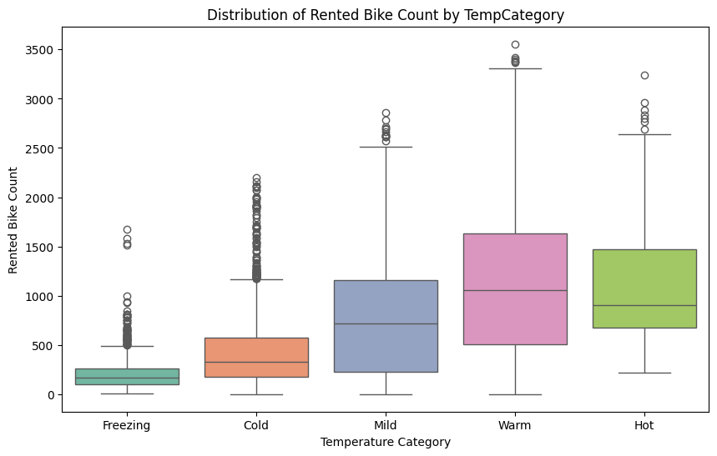
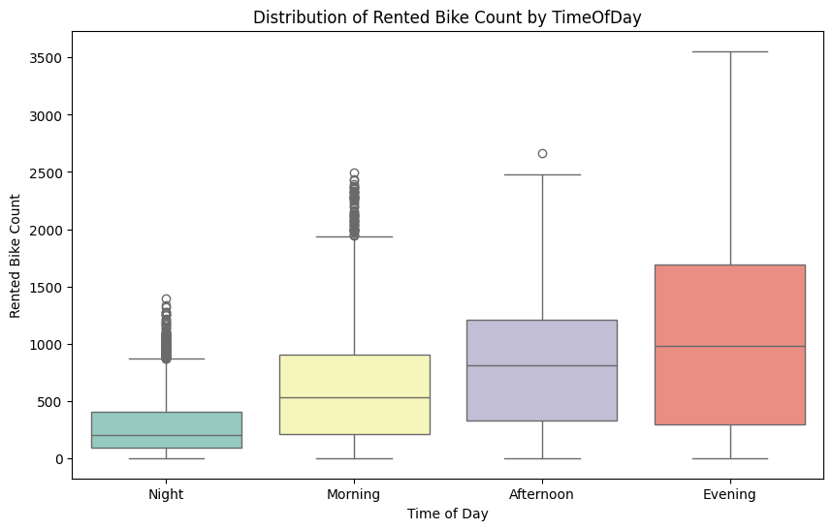

Feature Selection Summary
Based on correlation analysis and redundancy assessment, four key features were selected for modeling: Lag_1h, TempCategory, TimeOfDay, and Temp_x_Season. These features provide the most relevant information for predicting bike rentals while minimizing multicollinearity and maintaining interpretability for linear models.

4. Statistical Analysis of Selected Features
The 'Lag_1h' variable is a numerical measure, fluctuating between 0 and 3,556 hourly rentals, averaging at 704.56 with a standard deviation of 645.01. Displaying a considerable positive relationship (r ≈ 0.903) with what we're trying to predict, it emerges as the most impactful determining factor. The feature 'TempCategory' is a classification, represented by numbers ranging from 0 to 4, averaging 2.15, and it shows a fair relationship of 0.456. Similarly, 'TimeOfDay', another classification represented numerically, spans from 0 to 3 and presents a relationship of 0.443. The 'Temp_x_Season', a numerical interaction factor, ranges from -53.4 to 78.8 and demonstrates a relationship of 0.394.
To determine the extent of multicollinearity, an examination using Variance Inflation Factor (VIF) was performed. Every VIF measurement was less than 5, which suggests that the chosen factors do not show concerning linear relationships. This supports the use of linear regression models with confidence, without the risk of skewed results due to multicollinearity.
The combination of substantial relationships with the prediction target, various types of data, and minimal multicollinearity positions these four factors as appropriate for both straight-line and non-straight-line models. Quantifiable features offer forecasting strength, while classification and interaction features improve the model's adaptability. These chosen features strike a balance between being easy to understand and powerful in prediction, guaranteeing reliable performance across Linear Regression, Random Forest, and Gradient Boosting methods.
FIGURE 4: VIF for selected features
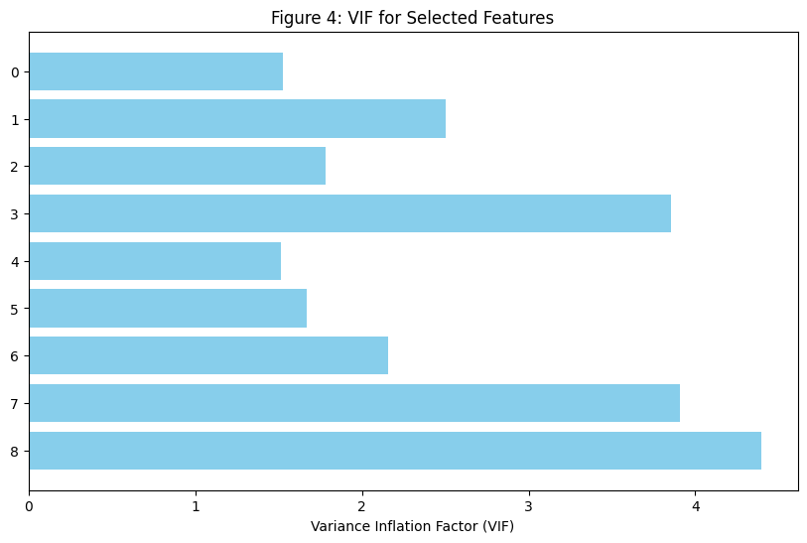

5. Model Development
5.1 Linear Regression
A Linear Regression model was trained using the selected features: Lag_1h, TempCategory, TimeOfDay, and Temp_x_Season. The model's effectiveness was reasonable, with an R² ≈ 0.828 and MSE ≈ 71,605, which suggests it accounts for roughly 83% of the fluctuation in the number of rented bikes. The Variance Inflation Factor (VIF) assessment verified that multicollinearity among the features is not substantial, guaranteeing trustworthy coefficient calculations.
Linear Regression offers clarity by demonstrating the explicit influence of each feature on the objective. To illustrate, Lag_1h significantly increases bike rentals, while factors such as TempCategory and TimeOfDay have less pronounced impacts. Nonetheless, the model's capacity to grasp intricate non-linear relationships and time-related trends is constrained, potentially diminishing predictive precision in fluctuating environments.
FIGURE 5: Linear Regression – predicted vs actual rentals
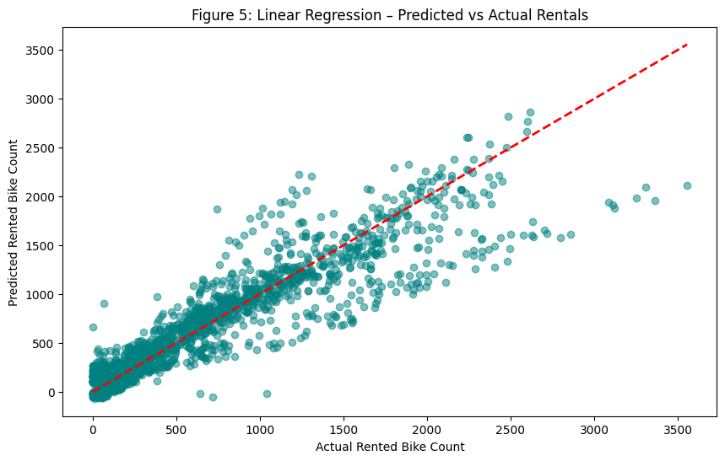

5.2 Random Forest Regressor
To model intricate links and interplay between features, a Random Forest Regressor was implemented. The performance of this model was noticeably superior when contrasted with Linear Regression, as it obtained an R² of approximately 0.871 and a MSE of roughly 53,737. It effectively models temporal dependencies and feature interactions, making it more accurate for predicting immediate rental demand.
Feature Importance analysis indicated that Lag_1h contributes approximately 89% of the predictive power, followed by Temp_x_Season at 4.9%, while categorical features like TimeOfDay and TempCategory have minimal influence. Bike usage is mainly determined by prior rental patterns and the interplay between temperature and seasons, as this clearly demonstrates. While the model is good at recognizing intricate trends, understanding it is not as simple as understanding Linear Regression.
FIGURE 6: Random Forest Feature Importances
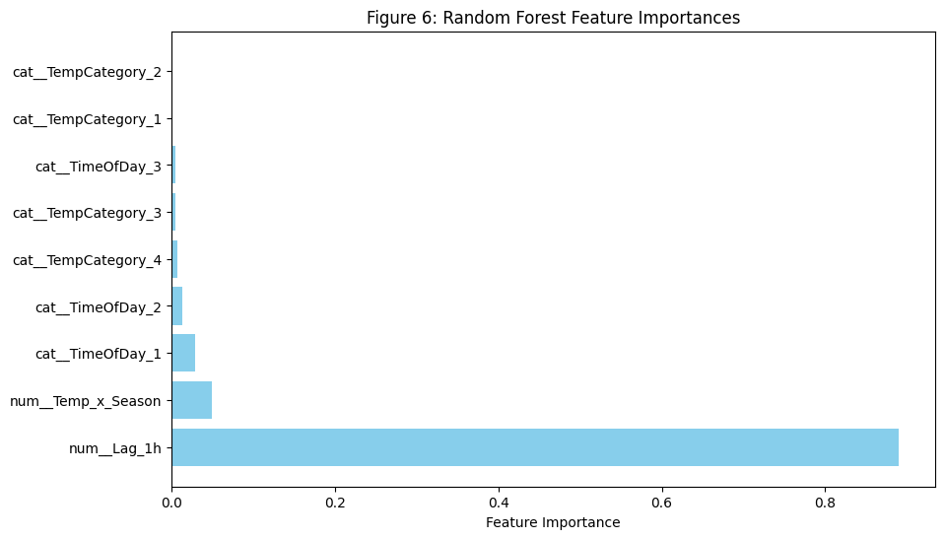
FIGURE 7: Random Forest – predicted vs actual rentals
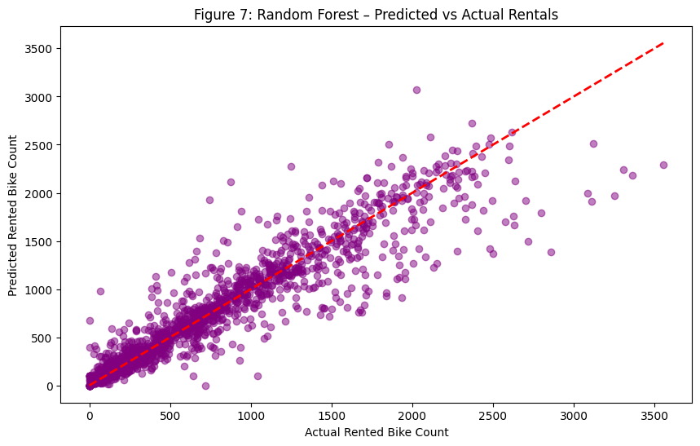

5.3 Gradient Boosting Regressor
By utilizing a repetitive method to fix mistakes in the sequence of trees, the Gradient Boosting Regressor makes it possible for the model to recognize minor variations and intricate patterns. The model performed marginally better than Random Forest, reflected by an R² of roughly 0.873 and an MSE of about 52,978, indicating a close correspondence between the predicted and real numbers of rentals. Feature importance analysis showed that Lag_1h dominates at 93.5%, while TimeOfDay and Temp_x_Season provide secondary contributions, and TempCategory has negligible effect. This emphasizes the critical role of recent temporal trends in bike rental prediction. Gradient Boosting excels in modeling non-linear relationships and minor variations in patterns, making it the most accurate choice, though individual feature interpretability is reduced compared to Linear Regression.
FIGURE 8: Gradient Boosting Feature Importances
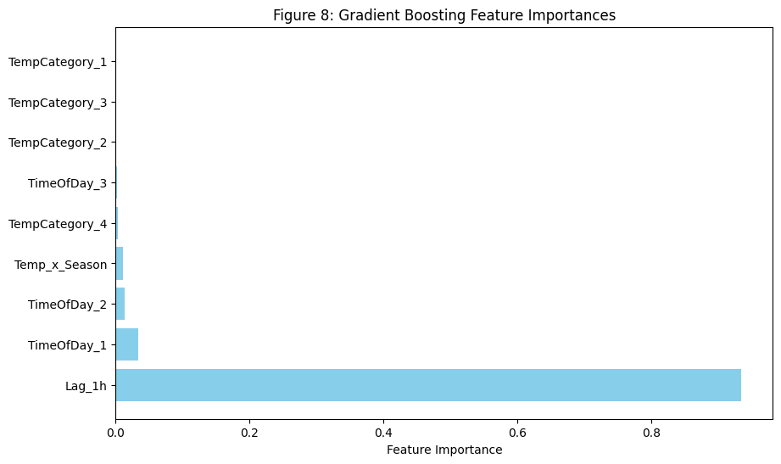 FIGURE 9: Gradient Boosting – predicted vs actual rentals
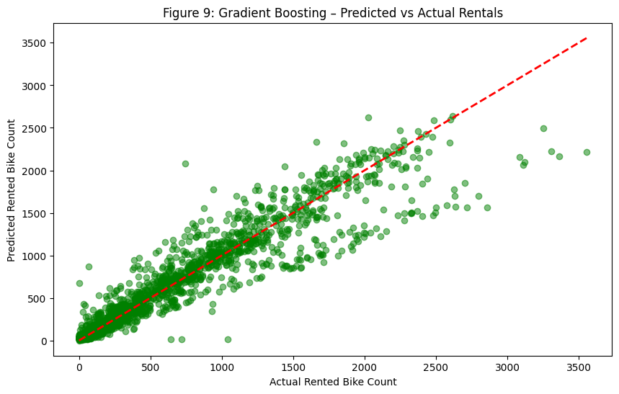

6. Discussion
Examining the three models side by side reveals how linear and non-linear methods differ. Linear Regression makes feature interpretation easy to understand and accounts for around 83% of the variability, but it has difficulty representing complicated non-linear relationships.
Non-linear models like Random Forest and Gradient Boosting do better than Linear Regression, with higher R² scores and lower MSE, which means they make more accurate predictions. Analyzing feature importance consistently showed that Lag_1h is the most important variable, which emphasizes how important recent rental patterns are for predicting demand.
While Random Forest is good at capturing non-linear feature interactions, Gradient Boosting makes accuracy better by repeatedly fixing errors that are left over, which handles small changes more accurately. Features like Temp_x_Season and TimeOfDay add to the predictions but are not as important as previous rental patterns.
In summary, the model you choose depends on what you want to achieve: if you want to easily understand how individual features affect things, Linear Regression is a good choice. If you want better prediction accuracy and to capture complicated patterns, non-linear ensemble methods, especially Gradient Boosting, are better.
7. Conclusion
This study explored the prediction of hourly bike rentals using temporal and environmental features. The analysis focused on understanding key drivers of bike usage and evaluating the performance of Linear Regression, Random Forest, and Gradient Boosting models. Among the features considered, Lag_1h, representing the previous hour’s rental count, consistently emerged as the most influential factor, highlighting the strong dependency of current demand on recent trends. Secondary features, including Temp_x_Season and TimeOfDay, contributed modestly, whereas TempCategory had minimal impact.
The results indicate that non-linear ensemble methods significantly outperform linear models in capturing complex patterns and interactions. Gradient Boosting achieved the highest predictive accuracy (R² ≈ 0.873, MSE ≈ 52,978), slightly surpassing Random Forest, demonstrating its strength in modeling subtle fluctuations and non-linear dependencies. Linear Regression, while slightly less accurate (R² ≈ 0.828), remains valuable for interpreting direct feature effects and understanding the relative importance of variables.
Overall, the study recommends Gradient Boosting for precise bike rental forecasting, especially when accurate predictions are critical for operational planning and resource allocation. The findings underscore the importance of incorporating temporal dependencies in predictive models and highlight the potential for extending these methods to anticipate future demand under varying conditions.

References
- UCI Machine Learning Repository (2020)
Title: Seoul Bike Sharing Demand Dataset
Description: Contains hourly bike rental data in Seoul along with weather and holiday information.
Available at: https://archive.ics.uci.edu/dataset/560/seoul+bike+sharing+demand
Accessed: 22 August 2025.
- Zhang, Y., Zheng, Y. and Qi, D. (2017)
Title: Deep spatio-temporal residual networks for citywide crowd flows prediction
Conference: AAAI Conference on Artificial Intelligence
Pages: 1655–1661
Available at: https://ojs.aaai.org/index.php/AAAI/article/view/10597
Accessed: 22 August 2025.
- Chen, T. and Guestrin, C. (2016)
Title: XGBoost: A scalable tree boosting system
Conference: Proceedings of the 22nd ACM SIGKDD International Conference on Knowledge Discovery and Data Mining
Pages: 785–794
Available at: https://arxiv.org/abs/1603.02754
Accessed: 22 August 2025.
- Breiman, L. (2001)
Title: Random forests
Journal: Machine Learning
Volume: 45
Pages: 5–32
Available at: https://link.springer.com/article/10.1023/A:1010933404324
Accessed: 22 August 2025.
- Pedregosa, F. et al. (2011)
Title: Scikit-learn: Machine learning in Python
Journal: Journal of Machine Learning Research
Volume: 12
Pages: 2825–2830
Available at: http://jmlr.org/papers/v12/pedregosa11a.html
Accessed: 22 August 2025.
- Hastie, T., Tibshirani, R. and Friedman, J. (2009)
Title: The Elements of Statistical Learning: Data Mining, Inference, and Prediction
Edition: 2nd edn.
Publisher: Springer
Available at: https://web.stanford.edu/~hastie/ElemStatLearn/
Accessed: 22 August 2025.
- Raschka, S. (2018)
Title: Python Machine Learning: Machine Learning and Deep Learning with Python, scikit-learn, and TensorFlow 2
Edition: 3rd edn.
Publisher: Packt Publishing
Available at: https://www.packtpub.com/product/python-machine-learning-third-edition/9781789955750
Accessed: 22 August 2025.

